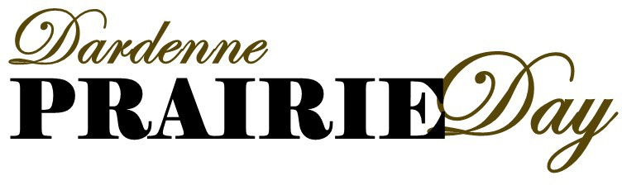
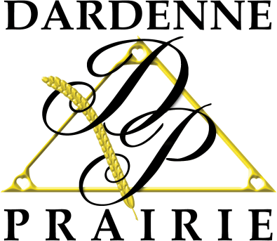
Sponsor Application
October 1
2022

Company/Organization:

Contact: Business Phone:

Day of Event Phone: E-Mail:

Address:

City: State: Zip Code:

Please indicate your level of sponsorship:

Bronze $1500 ______
- A booth at Prairie Day.
- Logo added to the Prairie Day page on the Dardenne Prairie website once your completed form is received. Also your logo will be posted on Dardenne Prairie’s Facebook page in the month leading up to the event.
- Added as a scavenger hunt spot in the City invitation to residents.

Gold $3000 ______
- All the benefits of the Bronze level.
- Logo placement in any Prairie Day advertisements.
- 2 banners provided by the City and placed on City Hall Park ground during Prairie Day.

- To participate as a sponsor, please contact Jennifer Bohn at (636)755-5333 or Jennifer.Bohn@dardenneprairie.org
- Checks may be made payable to, “City of Dardenne Prairie,” and mailed to City Hall, 2032 Hanley Road, Dardenne Prairie, MO 63368
- All sponsors are asked to provide a family friendly activity or giveaway during the event.
- Sponsor must provide own table, tent and chairs, unless other arrangements have been made.
- Please fill out a vendor application in addition to a sponsor application.

